


ISLAMIC UNIVERSITY OF TECHNOLOGY

PHY 4143: Physics II

Course Outline and Course Plan

IMPORTANT:

Contents of this Pro Forma shall not be changed without the Academic Council’s consent for items indicated with *. Changes to the other items can be approved at the Department/Faculty/Institution/Centre level.
Name of the Lecturer | Dr. Md. Sahab Uddin |  | Position |  |  | Professor
Department* | Software Engineering |  | Programme* |  |  | BSc.Eng.SWE
Course Code* | PHY 4143 |  | Course Title* |  |  | Physics-II
Academic Year | 2024-2025 |  | Semester |  |  | I Winter
Contact Hours* | 3 per week |  | Credit Hours* |  |  | 3.00
Medium of instruction* | English |  | Student Learning Time (SLT) * |  |  | 150 hours
Text books and Reference books (if any) | - Fundamentals of Electric Circuits by Charles K.Alexander and Matthew N.O.Sadiku  - Introductory Circuit Analysis, Pearson, by Robert L.Boylestad – 12 th Edition
Prerequisites  (If any) | None |  |  | Curriculum Requirement |  |  | Compulsory
Course Homepage  √ | To be done.
Teaching Methods/  Approaches | Lecture | √ Group discussion |  |  | √ Demonstration |  |  | √Problem solving
 | Project | √ Others: Case study
Teaching aids | √Multi-media | √ OHP |  |  | √Board and Marker |  |  | √Others
Methodologies for feedback on performance | - Discussions in class. | - Returning graded quizzes/test and assignments. |  |  | - Mid-semester marks announcement. |  |  | - Final grades announcement.

Course Assessment Plan
Course Assessment Method
Attendance (10%) | Quiz 20% of Total Marks |  |  |  |  |  | Mid Semester (40%) | Semester Final (40%)
Based on % of attendance. | 1st Quiz | 2nd Quiz | 3rd Quiz | 4th Quiz | Others |  | Week/Date | Week/Date
 | Week/Date | Week/Date | Week/Date | Week/Date | Assignment | Case study
 | 4th week | 6th week | 10th week | 12th week | None | Along the course | To be announced | To be announced

Syllabus of the Course
Course Contents / Syllabus
Electrical Units and Standards. Electrical Networks, Circuit solution, Series and Parallel networks, Loop and Nodal methods. Delta-Wye Transformation, Circuit Theorems: Superposition theorem, Thevenin’s and Norton’s Theorem, Concept of Dual Networks, Basic principle of generation of Alternating and Direct Current, Introduction to Phasor algebra as applied to A.C. Circuit analysis, Solution of A.C. circuits: Series circuits , Parallel and Series-Parallel circuit, R.L.C circuits, Series and parallel resonance. Applications of Networks theorems to A.C. circuits. The magnetic intensity, flux/density, magnetic effects of Electric current, Magnetic circuit concepts, BH curve, Classification and characteristics of magnetic materials, Magnetic force and its utilization, Hysteresis and eddy current losses, Magnetic circuit with A.C. and D.C. excitation.

Course Objectives
Course Objectives
This course is designed for the SWE students for the following objectives:
1. To learn Electrical Units and Standards. Electrical Networks
2. To examine phenomena of Loop and Nodal methods.
3. To describe Delta-Wye Transformation
4. To understand Circuit Theorems: Superposition theorem.
5. To understandThevenin’s and Norton’s Theorem, Concept of Dual Networks.
6. To understand Basic principle of generation of Alternating and Direct Current,
7. To understand Phasor algebra as applied to A.C. Circuit analysis.
8. To find Parallel and Series-Parallel circuit, R.L.C circuits ,
9. Applications of Networks theorems to A.C. circuits.
10. The magnetic intensity, flux/density, magnetic effects of Electric current,
11. Magnetic circuit concepts, BH curve
12. Classification and characteristics of magnetic materials
13. Magnetic force and its utilization, Hysteresis and eddy current losses
14. Magnetic circuit with A.C. and D.C. excitation

Course Outcomes (CO) Statement
Mapping with CO, PS and Bloom’s Taxonomy
CO No | Course Outcomes (CO) Statement | Levels of Bloom’s Taxonomy | Matching with Program Outcome (PO)
CO1 | Explain the basic concepts of electric circuits, including voltage, current, resistance, impedance, and the behavior of R, L, and C components in AC and DC circuits. | C1 | PO1
CO2 | Apply Ohm’s Law, Kirchhoff’s Laws, Nodal analysis, Mesh analysis, Wye-delta transformation, phasor techniques, and major circuit theorems (Thevenin, Norton, and superposition) to analyze and solve AC and DC circuits. | C2 | PO2
CO3 | Analyze magnetic fields and magnetic circuits—including magnetic intensity, flux density, magnetic materials, BH characteristics, magnetic forces, hysteresis and eddy current losses | C3 | PO2

CO-PO Mapping with Levels
Mapping of COs and POs [Correlation level 1 for low, 2 for moderate and 3 for high]
Course Outcomes | PO1 | PO2 | PO3 | PO4 | PO5 | PO6 | PO7 | PO8 | PO9 | PO10 | PO11 | PO12
CO1 | 2
CO2 |  | 2
CO3 |  | 3

Methods of Course Delivery and Assessment
CO No. | Course Outcomes (CO) Statement | METHOD OF  DELIVERY | METHOD OF  ASSESSMENT
CO1 | Explain the basic concepts of electric circuits, including voltage, current, resistance, impedance, and the behavior of R, L, and C components in AC and DC circuits. | Lecture/Students feedback/Tutorial | Tests/Quiz/Assignment/Case study/Viva
CO2 | Apply Ohm’s Law, Kirchhoff’s Laws, Nodal analysis, Mesh analysis, Wye-delta transformation, phasor techniques, and major circuit theorems (Thevenin, Norton, and superposition) to analyze and solve AC and DC circuits. | Lecture/Students feedback/Tutorial | Tests/Quiz/Assignment/Case study/Viva
CO3 | Analyze magnetic fields and magnetic circuits—including magnetic intensity, flux density, magnetic materials, BH characteristics, magnetic forces, hysteresis and eddy current losses | Lecture/Students feedback/Tutorial | Tests/Quiz/Assignment/Case study/Viva

Weekly plan for course content
Weeks | Topics | Task/Reading
1 | 1. Introduction to Electric units circuits  2. Fundamental of electric circuits, Kirchoff’s laws
2 | 1. Loop and Nodal methods  2. Principles of Delta-Wye Transformation,
3 | 1 Circuit Theorems: Superposition theorem  2. Thevenin’s and Norton’s Theorem
4 | 1 Thevenin’s and Norton’s Theorem.  2. Concept of Dual Networks, | Quiz 1
5 | 1. Basic principle of generation of Alternating and Direct Current  2. DC and AC Motors, Generators
6 | Introduction to phasor algebra as applied to A.C.circuit analysis | Quiz 2
7 | Solution of A.C. circuits: Series, Parallel and Series-Parallel circuit R.L.C  circuits series and parallel resonance
8 | Applications of Networks theorems to A.C. circuits,The magnetic intensity, flux/density,Electromagnet
9 | Magnetic effects of Electric current, Amperes law, Magnetic Torque. Magnetic circuit concepts
10 | Classification of magnetic materials Time varying magnetic field | Quiz 3
11 | Faradays law of electromagnetic induction, Induced current , Lenz’s law. Eddy Current, Origin of eddy current and its applications
12 | Hysteresis and Eddy current loss  Magneti circuits with ac and dc excitation | Quiz 4
13 | Magnetic hysteresis curves, Magnetic domain
14 | Magnetic Susceptibilty, A.C. and D.C. Susceptibilty
15 | Semester Final Examination

PLOs/POs of CSE Programme, IUT
PLOs/POs of CSE Programme, IUT : The below list for CSE needs to be filled out as per the
PLOs/POs of CSE Programme, IUT
E

PO No. | PLOs/POs of ME Programme, IUT | Taxonomy | PEO Mapping
 | Upon graduation, (after Four years of studies), a student of Mechanical Engineering (B.Sc. Mech. Eng.) will attain the following abilities:
PO1 | Engineering knowledge: Apply knowledge of mathematics, natural science, mechanical engineering fundamentals and its engineering specialization as specified in K1 to K4 respectively to the solution of complex engineering problems. | Cognitive | PEO1
PO2 | Problem analysis: Identify, formulate, research literature and analyze complex mechanical engineering problems reaching substantiated conclusions using first principles of mathematics, natural sciences and engineering sciences. (K1 to K4) | Cognitive | PEO1
PO3 | Design/development of solutions: Design solutions for complex engineering mechanical problems and design systems, components or processes that meet specified needs with appropriate consideration for public health and safety, cultural, societal, and environmental considerations. (K5) | Cognitive/Psychomotor | PEO1
PO4 | Investigation: Conduct investigations of complex problems using research-based knowledge (K8) and research methods including design of experiments, analysis and interpretation of data, and synthesis of information to provide valid conclusions. | Cognitive | PEO2
PO5 | Modern tool usage: Create, select and apply appropriate techniques, resources, and modern engineering and IT tools, including prediction and modeling, to complex mechanical engineering problems, with an understanding of the limitations. (K6) | Affective/Psychomotor | PEO3
PO6 | The engineer and society: Apply reasoning informed by contextual knowledge to assess societal, health, safety, legal and cultural issues and the consequent responsibilities relevant to professional engineering practice and solutions to complex engineering problems. (K7) | Cognitive | PEO1
PO7 | Environment and sustainability: Understand and evaluate the sustainability and impact of professional engineering work in the solution of complex engineering problems in societal and environmental contexts. (K7) | Cognitive | PEO1
PO8 | Ethics: Apply ethical principles and commit to professional ethics and responsibilities and norms of engineering practice. (K7) | Affective | PEO2
PO9 | Individual work and teamwork: Function effectively as an individual, and as a member or leader in diverse teams and in multi-disciplinary settings. | Affective | PEO2
PO10 | Communication: Communicate effectively on complex engineering activities with the engineering community and with society at large, such as being able to comprehend and write effective reports and design documentation, make effective presentations, and give and receive clear instructions. | Cognitive/ | PEO3
PO11 | Project management and finance: Demonstrate knowledge and understanding of engineering management principles and economic decision-making and apply these to one’s own work, as a member and leader in a team, to manage projects and in multidisciplinary environments. | Affective/Psychomotor | PEO3
PO12 | Life-long learning: Recognize the need for, and have the preparation and ability to engage in independent and life-long learning in the broadest context of technological change. | Cognitive | PEO2

Source: http://www.baetebangladesh.org/poa.php
(Board of Accreditation for Engineering and Technical Education, Bangladesh) with minor modification for ME, IUT programme.

Mapping of Course Outcomes (COs) and Evaluation Methods

Assessment Method | Marks | CO1 | CO2 | CO3 | Final
 |  | PO1 | PO2 | PO2
Class test/quiz I, Quiz II/Quiz III/Quiz IV | 20% (60) | 10% | 10% |  | Class performance
Attendance (Class Participation) | 0% | - | - | - | Attendance and Class performance
Midterm Exam. | 40%  (120) | 30% | 10% |  | As obtained
Final Exam. | 40%  (120) | 30% | 10% |  | As obtained
Total | 100% (300) |  |  |  | As obtained

Student Learning Time
NO. | Teaching and Learning Activities | Student Learning Time (SLT): Notional Hours
1 | Lectures | 36 hours
2 | Tutorial | 4 hours
4 | Assignment/case studies/Tests | 12 hours
5 | Personal study | 60 hours
6 | Cooperative learning | 8 hours
TOTAL SLT |  | 120 hours
CREDIT = SLT/40 |  | 3

K
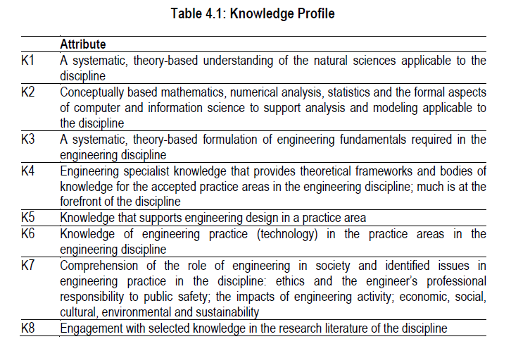

P
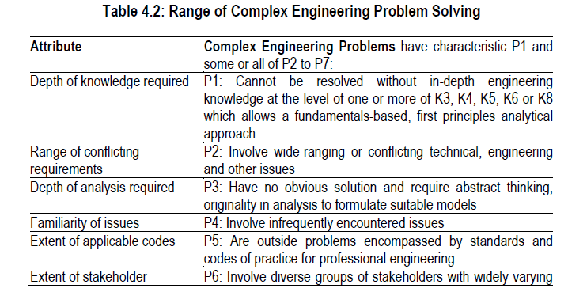
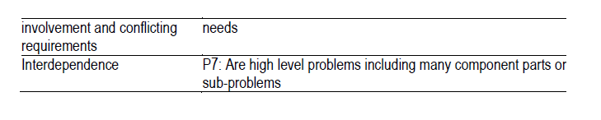

A
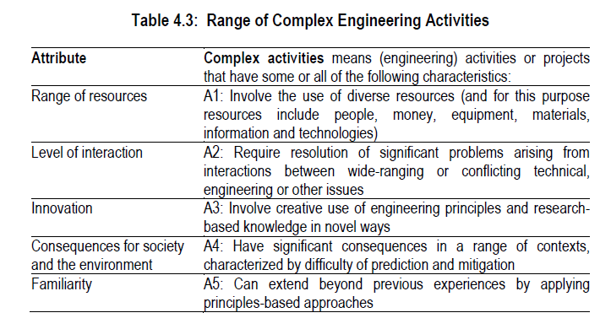
Grading Policy

Numeric Grade | Letter Grade | Grade Point
80% and above | A+ | 4.00
75% to less than 80% | A | 3.75
70% to less than 75% | A- | 3.50
65% to less than 70% | B+ | 3.25
60% to less than 65% | B | 3.00
55% to less than 60% | B- | 2.75
50% to less than 55% | C+ | 2.50
45% to less than 50% | C | 2.25
40% to less than 45% | D | 2.00
Less than 40% | F | 0.00

Class Schedule / Class Routine

Section | Day | Time and day
SWE | Monday  Tuesday | 8:00 AM – 9:15 AM  508  2.30 PM- 03.45 PM  125 | 9:15AM-10:30AM  11:45 AM – 1:00 PM

Teacher/Lecturer of the Course
Name: Dr. Md. Sahab Uddin
Position: Professor
Cell no: 01710059612
Email: sahabuddin@duet.ac.bd

